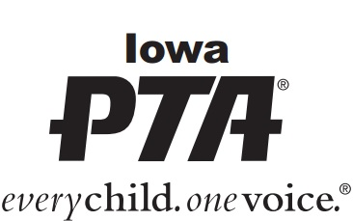
Monthly submission of dues is recommended. The annual State and National PTA membership period is July 1 – June 30. More information on Membership can be found in the Running Your PTA section of the Iowa PTA website at www.iowapta.org.
When remitting dues to the State Office, annual State and National membership dues should be included in one check payable to Iowa PTA in the amount of $4.75 per individual (National $2.25/member and State $2.50/member). The Iowa PTA remits dues directly to National PTA monthly. Questions? Please email us at info@iowapta.org.
Please mail check and this form to: Iowa PTA
PO Box 10634
Cedar Rapids, IA 52410

Please email your current membership in an excel spreadsheet to info@iowa.org using the Iowa PTA Local Unit Membership Roster. If unable to submit electronically, contact info@iowa.org.

Complete Name of Local PTA/PTSA ________________________________________________
Mailing Address ______________________________ City ______________ Zip_____________

President___________________________________________ Phone ___________________
Email _______________________________________________________________________

Treasurer___________________________________________ Phone ___________________
Email _______________________________________________________________________ Signature of Treasurer_______________________________ Date: ____________________
PLEASE COMPLETE THE FOLLOWING INFORMATION:
Have you filed your IRS Form 990, 990-EZ, or 990-N for the 2018 fiscal year? oYes oNo
Have you completed the PTA/PTSA audit for the fiscal year ending in 2019? oYes oNo
Did you send a copy of both forms to the state PTA office? oYes oNo
Did you submit a copy of the PTA/PTSA membership list as required? oYes oNo

This payment covers dues received from: Membership Year o 2019/2020 Late Dues for o 2018/2019
oJul oAug oSep oOct oNov oDec oJan oFeb oMar oApr oMay oJun
Total # of members ______ x $4.75/member = $__________

#everychildonevoice #yourmembershipmatters

