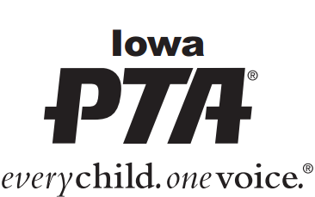

Name

Address

Amount $

_____ I would like to make a one-time, tax-deductible donation to Iowa PTA

_____ I would like to make an annual, tax-deductible gift to Iowa PTA

_____ I would like to make a memorial gift to Iowa PTA

In Memory of: _______________________________________

May we include your name on our donor list? (YES / NO)
May we include the decedent’s name on our donor list? (YES / NO)

If you would like a letter sent to the family of the deceased telling them that a memorial was given, please provide contact information below.

Name

Address

Please mail completed form to: Iowa PTA
PO Box 10634
Cedar Rapids, IA 52410

Please make checks payable to Iowa PTA.

For more information call 1-319-573-0049 or e-mail info@iowapta.org

10/19 jnm

