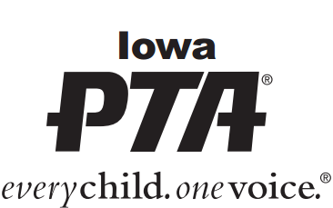
Bylaws Submission Form
Always submit an electronic copy of bylaws.

Electronic submissions must be emailed in a Word format
Attn: Bylaws Chair @ info@iowapta.org

Name of Local PTA Unit: ________________________________________________________
(Legal name of the PTA)

Submitted to Iowa PTA following approval by the general membership on ___________________ (date).

Each PTA should have a standing committee that reviews the bylaws every year to make sure they are still applicable to your unit. The committee should update the required items as needed. Amendments to the bylaws which are made at the State PTA Conventions do not require any action by your PTA, but do need to be incorporated into your bylaws immediately.

The latest Local Unit Bylaws Template can be accessed through the Iowa PTA website: http://www.iowapta.org/index.php/for-leaders/bylaws.

Always submit an electronic copy in a Word format. If changes have been made submission must include a list of amendments made to the document.

Please check all that apply (*Required):
______ Submitting revised copy of bylaws with date of approval by general membership.

______ No Amendments made. Bylaws reapproved by current general membership.

______ Amendments made, and a list submitted for review.

______ Minutes including approval of submitted bylaws by general membership. *

Person to whom bylaws should be returned: ________________________________________________

Address: _______________________________ City: ___________________ Zip: __________________

_______________ ______________________________________________________________
Phone Number *Email Address (required if bylaws are sent electronically)

When bylaws are approved, Iowa PTA e-mails a copy containing the approval stamp to the person indicated above.

If bylaws are not approved, an email response will be sent explaining the needed corrections.

If you have any questions regarding this information, please contact:
Iowa PTA PO Box 10634 (319) 573-0049 - phone info@IowaPTA.org
Cedar Rapids, IA 52410 www.IowaPTA.org

